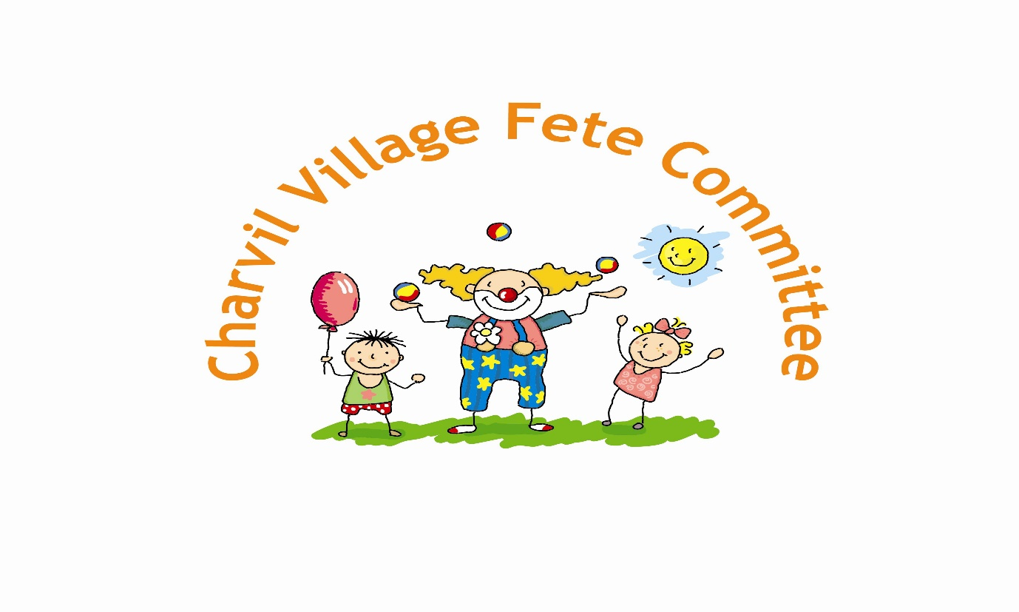
IMPORTANT ANNOUNCEMENT
2nd Extra Ordinary General Meeting

At the 2017 Charvil Village Fete AGM & EOGM held on 10th October 2017 no committee was formed to run the 2018 fete. A 2nd EOGM has been scheduled for the 6th November 2017 at 48 Park View Drive North, Charvil at 8pm to elect a new committee.

Any interested parties should attend this meeting and we look to elect the positions of Chairman, Secretary, Treasurer and committee members.

Mark Donlan (Secretary) – Tel 07782 326036.

